ICS 344 – PROJECT
Phase 3: Defensive Strategy Proposal

In this phase, we designed and implemented two primary defensive tools to protect our vulnerable SSH service on Metasploitable3 and to monitor attacker behavior:

Fail2ban: An intrusion prevention framework that scans log files (/var/log/auth.log) and bans IPs exhibiting malicious patterns such as repeated failed SSH login attempts.

Cowrie Honeypot: A high‑interaction SSH honeypot deployed on Kali Linux to divert and log attacker traffic, providing detailed session information for analysis.

Implementation Details:
See README file for details.

Testing & Validation

Fail2ban Effectiveness

Pre-defense: Repeated failed SSH login attempts from attacker IP were successful without bans.

Post-defense: After three failures, the attacker IP was auto-banned for one hour.

Validation Command:

sudo fail2ban-client status sshd

Expected Output: shows our IP in the banned list.

Cowrie Monitoring

Engagement: Attacker connects via SSH to port 22 and traffic is redirected to Cowrie on 2222.

Log Capture: Cowrie logs full session transcripts, attempted commands, and any file downloads.

Before-and-After Comparison
SSH Brute‑Force Attempts

Before: Unlimited login attempts allowed

After: IP blocked after 3 failed attempts

Attacker Session Logging

Before: Only standard auth logs captured
After: Complete honeypot session transcripts

Screenshots:
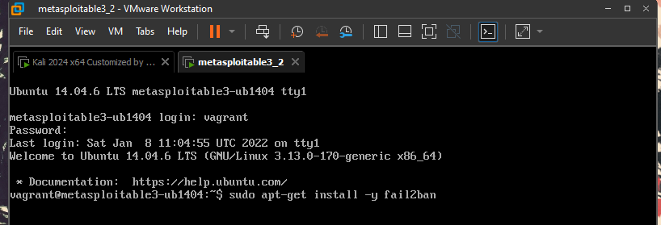
Installing Fail2ban on Metasploitable3
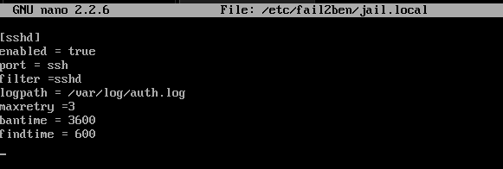
Ban IP for 1 hour after three failed login attempts.
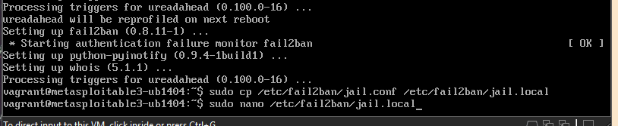
istalled Fail2ban and copied its config file
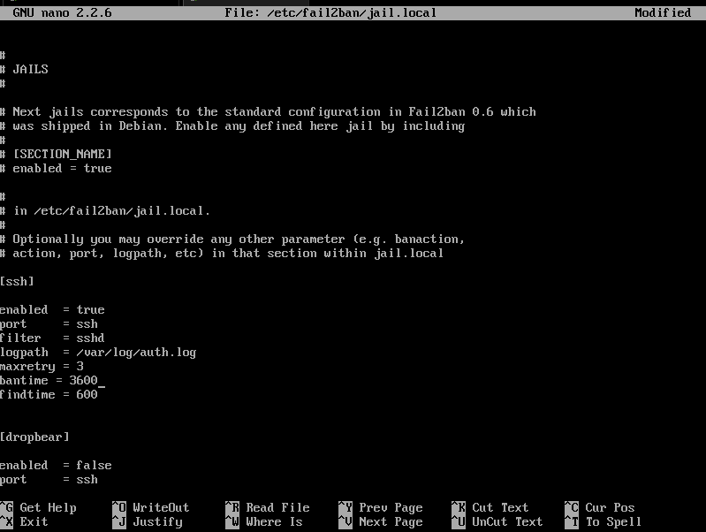
SSH protection is on, Dropbear protection is off
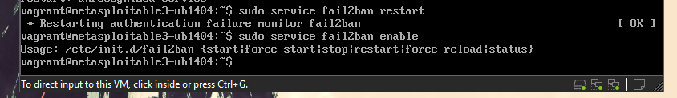
Fail2ban restarted successfully; ‘enable’ isn’t a valid command
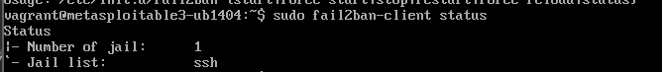
SSH protection is active
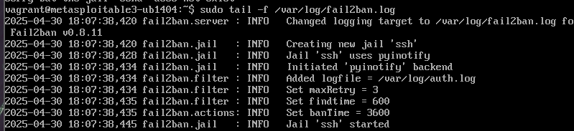
Fail2ban is now active and monitoring SSH login attempts
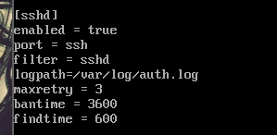
SSH now locks out after three failed attempts for one hour
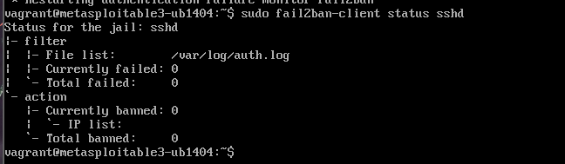
No failed logins or bans
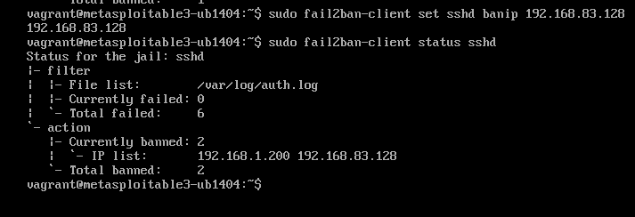
Six failed logins recorded; two IPs (192.168.1.200 and 192.168.83.128) are now blocked.
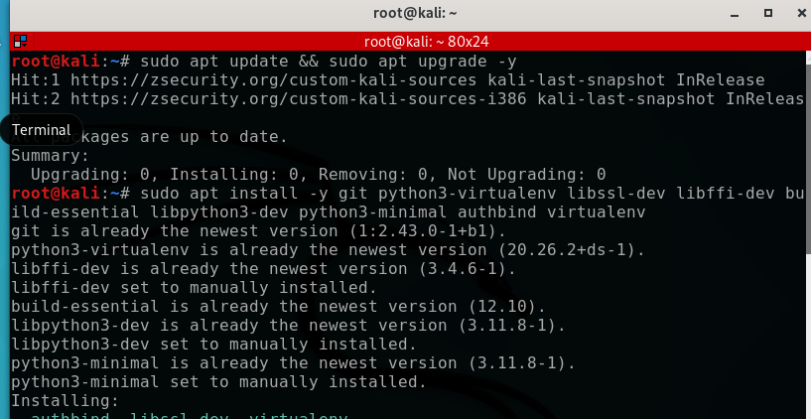
System updated and required tools installed
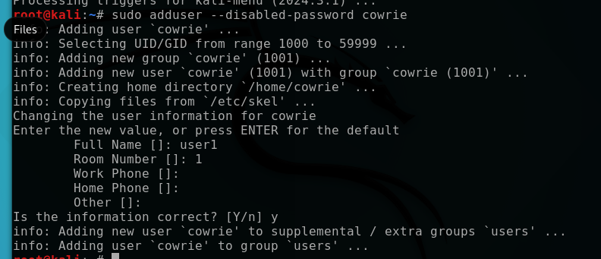Added the ‘cowrie’ user account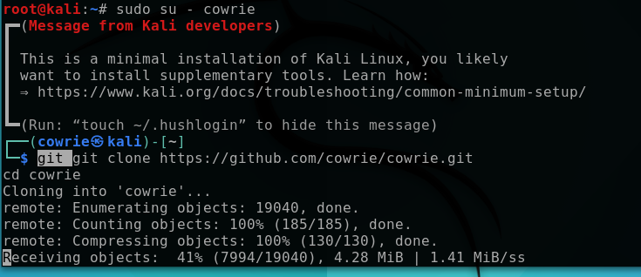
Cloned the Cowrie honeypot code from githu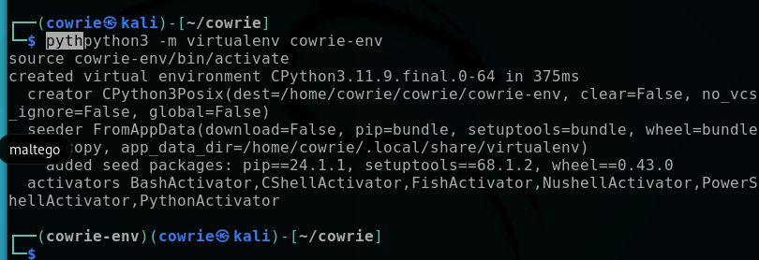
Created and activated the Python virtual environment for Cowrie
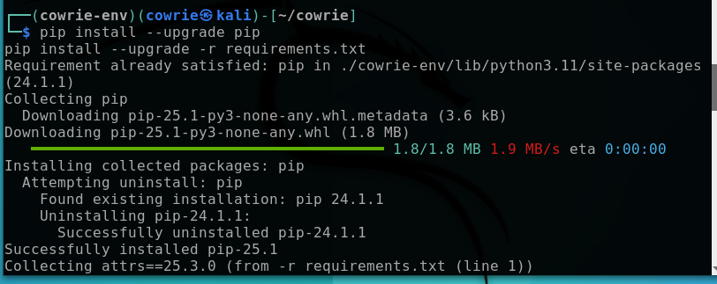Upgraded pip and installed Python requirements
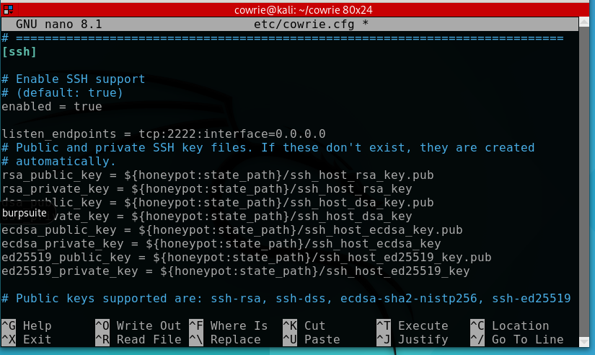
SSH honeypot listening on port 2222
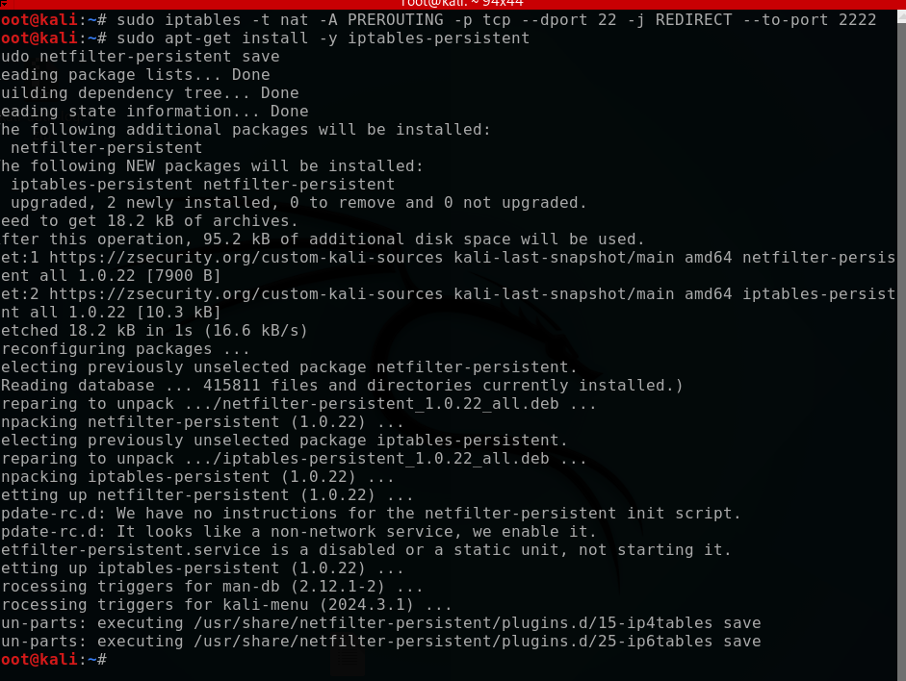
All SSH connections on port 22 are now sent to port 2222 and the change is saved permanently.
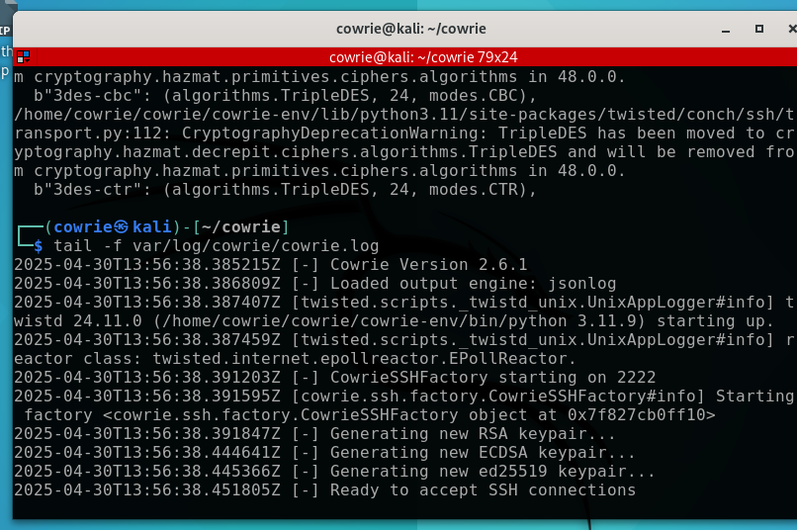
Cowrie honeypot started and is now listening for SSH connections
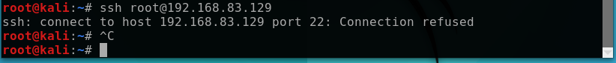
SSH on port 22 is refusing connections
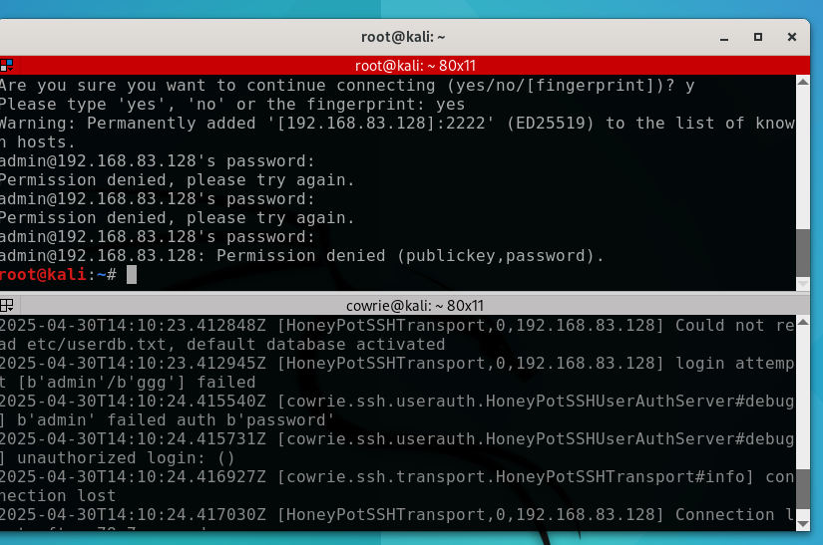
Real SSH refused; honeypot captured failed login attempts

Conclusion:

The combined deployment of Fail2ban and Cowrie significantly improved the security posture of our SSH service. We successfully demonstrated prevention of brute-force attacks and enhanced visibility into attacker tactics, fulfilling Phase 3 requirements.

